MORNING WORSHIP SERVICE
March 29, 2015

Opening Song “Are You Washed in the Blood” 136

Opening Prayer

Announcements

Worship Hymns “At the Cross” 139
“Sweet, Sweet Spirit” 243
“Nothing but the Blood” 135
“only Believe”
“My Only Hope Is you”

Offering/Offertory

Special Music Curtiss Waggoner

Message Bro. David Atwood

Invitation “Have Thine Own Way” 294
Closing Prayer

NURSERY – available for children age 0 to Kindergarten
Jana Moore

Hostesses for March Ushers for March
Judy Broussard, Terri Edwards, Kenny Merrell, David Condron,
Hugo & Carolyn Breithaupt Sam McManus, Jimmy Miller

Prayer & Request Information

(Please complete name & address information on reverse side)

I would like to speak with the Pastor.

I would like more information on this church.

I have Prayer Requests or Needs

Date:

Permission to Publicize:
Church Bulletin Yes No
Email Prayer Chain Yes No

Prayer Request:

Prayer For
Name
Address
Phone

Given By
Name
Address
Phone
Please Contact By

Card Phone Visit

Comments

Immediate Need Prayer List

Pray for Barbara Marchbanks as she deals with cancer issues

Pray for Connie Kahlstrom as she recovers from surgery

Pray for the families in the area that have recently lost loved ones

Pray for unsaid needs

Pray for our Pastor Search Committee

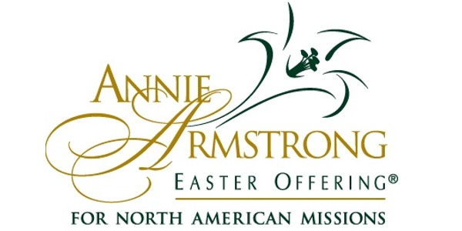

K s b c

Keeping His Word through Sunday School, Bible Study and Church Attendance/Worship

Sunday School Bible Studies for March:

Mar. 1st Promised Like No Other Isaiah 53:2-12 Mar. 8th A Birth Like No Other Luke 1:26-35
Mar. 15th Power Like No Other Mark 4:35-41
Mar. 22nd Teachings Like No Other Mark 1:21-22; 10:17-22
Mar. 29th A Death Like No Other Mathew 27:28-31, 45-50, 54

9:45 a.m. each Sunday – A place for everyone

WE’D LOVE FOR YOU TO JOIN US!

